**How to import CSV files into the table objects created:**

1. Locate the database created in the object explorer and then navigate to schemas> tables.
2. A screenshot of a computer

   Description automatically generatedRight click on each table per import and select ‘Import/Export Data’.
4. A screenshot of a computer

   Description automatically generatedBrowse to the Resources directory where each CSV file has been saved and ensure the format has been recognised as CSV. You can also set an encoding based on the data contained within the file.
5. Select on the columns tab and ensure the columns to import are correct and click OK.

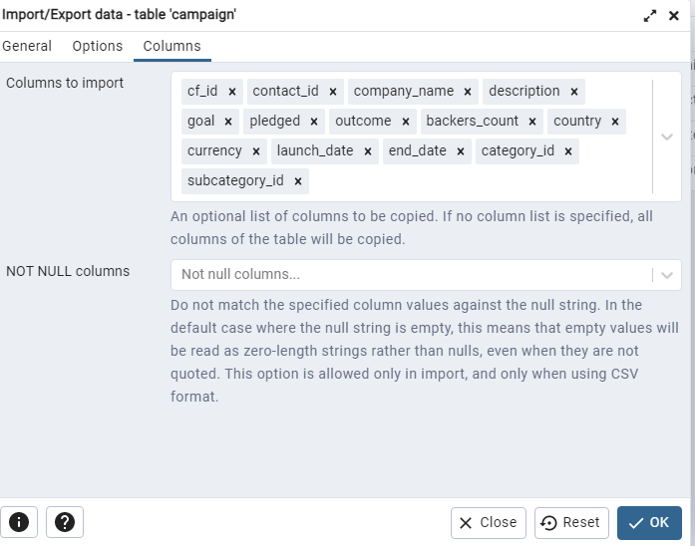

1. Once completed for each table you will see the success messages:

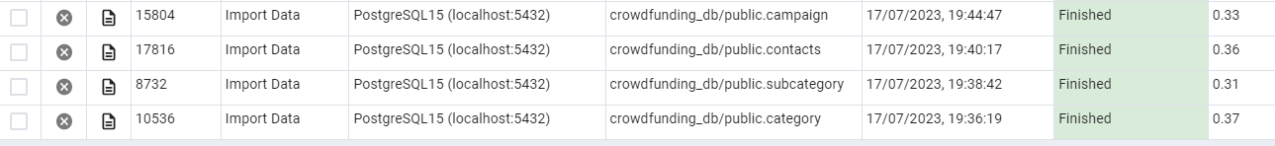

1. You can also run the SELECT statements in the crowdfunding_db_schema to view that the data has imported correctly:

